***STUDENT MARKS INPUT & VALIDATION***

**Features to Implement:**

* Input: Student name + 3 subject marks
* Validate:
  + Try-Catch for format errors (non-numeric input)
  + Range validation for marks (0–100)
* Calculate average
* Print Pass/Fail based on average (e.g., pass if avg >= 40)
* Use finally block

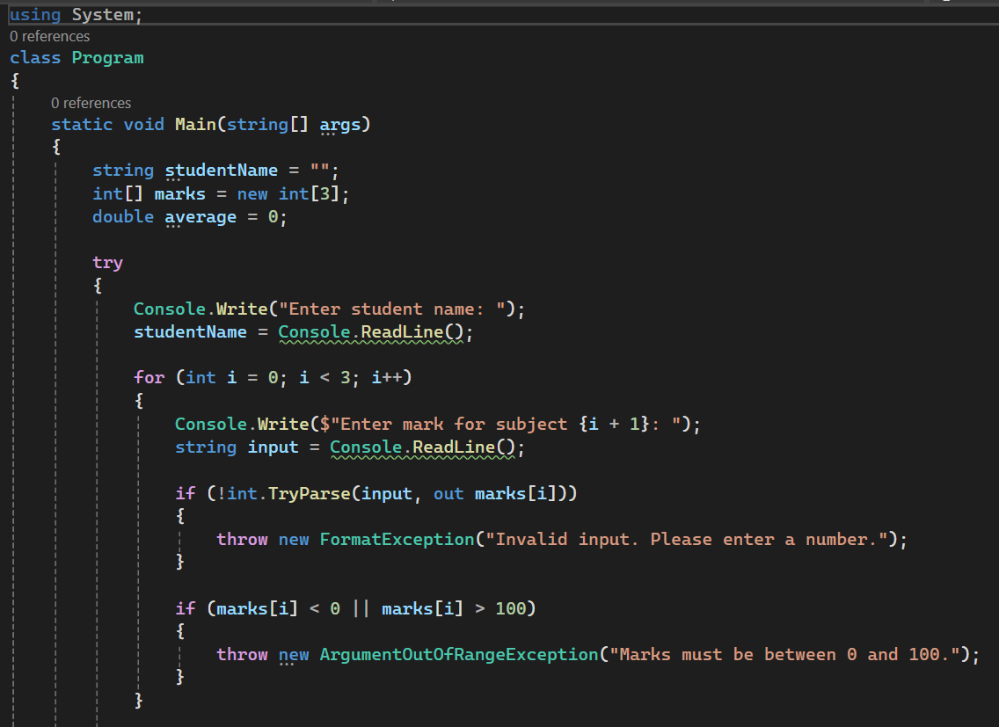

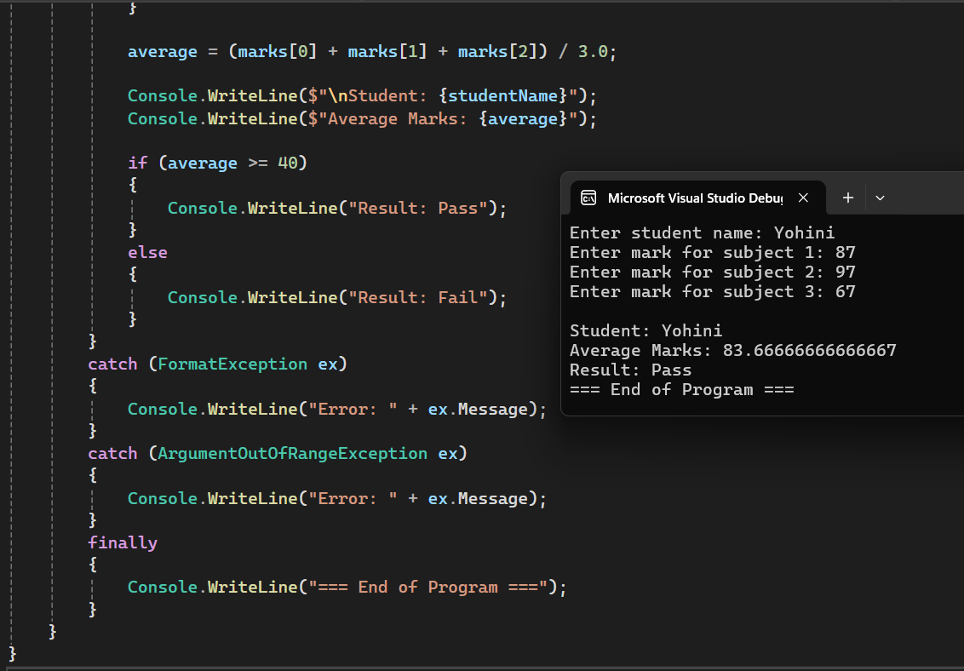

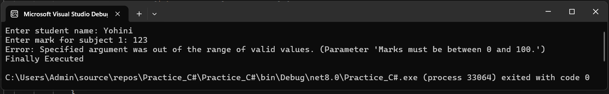

***CUSTOM EXCEPTION FOR STUDENT ID VALIDATION***

**Features to Implement:**

* Create Student class (with ID, Name)
* Custom exception: InvalidStudentIDException
* Throw if ID is not 5-digit
* Catch and display error in Main

